ESM206-assignment4

Claire Madden, Bridget Gibbons, Andrew Paterson

11/12/2018

**Introduction**

Following decades of highly and increasingly efficient fishing methods in California, many commercial fish stocks are dangerously depleted.  While this is fairly well known, the cascading effects of these depleted fish stocks on the broader marine ecosystem of the California Coast are more complex and less understood.  In order to maintain a balance between the demands of the commercial fishing industry and a healthy and robust ecosystem, further research into the ramifications of fishing practices and methods to mediate these negative impacts is essential.

Since the extirpation of the sea otter in Southern California oceans in the late 1800s, the spiny lobster is the primary animal regulating sea urchin populations on the ocean floor.  This role is especially important because sea urchins feed on the holdfasts of kelp, which anchor the massive plants to the ocean floor. Left unchecked, sea urchins will, and in some parts of California, have decimated the enormous kelp forests that once filled the coastal California waters $^2$.  These kelp forests form an ecosystem that hundreds of different marine species rely on for some part of their life cycle, including many popular commercial fish stocks. Without them, in addition to the intrinsic loss of value and ecological diversity, further ecological impacts and reductions in fishing stocks should be expected.

Here, we examine the spiny lobster (*Panulirus interruptus)* in the Santa Barbara Channel*,* and the impact of Marine Protected Areas on the average size and vitality of this important predator and popular seafood item.  Marine Protected Areas are employed for a variety of purposes, from preserving public resources to sustaining fisheries. The Santa Barbara Channel Marine Protected Areas were established in 2012 and are no-take regions, meaning any kind of fishing is not allowed $^3$.  They provide a region for marine life to spawn and mature, including the spiny lobster $^1$. Theoretically, spiny lobsters caught and measured in Marine Protected Areas should be larger than those caught in non-Marine Protected Areas. If reflected in the data, it is a positive omen for the future health of California Kelp forests and their associated ecosystems, and potentially provides justification for the creation of more Marine Protected Areas in California and elsewhere, though this claim is beyond the scope of our report and research.

The following report analyzes spiny lobster abundance and carapace sizes, along with fishing pressure at five Long-Term Ecological Research (LTER) sites in the Santa Barbara Channel from 2012 to 2017.  Two locations, Isla Vista and Naples Reef, are in Marine Protected Areas, and the remaining three, Mohawk Reef, Arroyo Quemado, and Carpinteria, are in unprotected areas. Lobster sizes and abundance in these locations are compared against local fishing pressures, as measured by the count of commercial lobster trap buoys at nine locations along the coastline, to determine the effect of Marine Protected Areas on the size and abundance of spiny lobsters.

**Data, Data Analysis, and Statistical Methods**

To demonstrate the trends in lobster abundance and fishing pressure between the five research sites from 2012 - 2017 the data for total annual lobster abundance between sites, and fishing pressure (indicated by total annual number of recorded commercial trap buoys) between sites were each graphed over the same five-year period.

To compare lobster carapace length between the five LTER sites in 2017, we first created and examined exploratory quantile-quantile plots and histograms of the carapace size distribution at each site.  The distributions looked normal, and sample sizes at each site were greater than 30, so the Central Limit Theorem applied. We then conducted a Levene’s Test to test the null hypothesis of equal variances among all sites and determine if ANOVA was applicable.  With p < .001 we rejected the null hypothesis of equal variance in carapace size among all locations. However, we examined a summary table of variances at each site and determined that the largest variance is much less than four times the smallest variance, so we could assume equal variances and proceed with ANOVA. Our ANOVA test suggested there was at least one difference in mean carapace size between lobsters at the five locations. We then used Tukey’s HSD to determine which sites differed in mean lobster carapace size, and conducted a Cohen’s D test between each resulting pair of sites to determine the magnitude of these differences.

In order to determine whether or not there were significant changes in lobster sizes from 2012 to 2017 within each LTER site, we first created exploratory histograms and quantile-quantile plots for each location. The distributions of lobster sizes in 2012 and 2017 looked relatively normal across all 5 sites, so it was determined that a two-sided, two-sample T-Test was appropriate. An F-Test for equal variances was conducted for each location, and in all cases p values were found to be greater than 0.05. Based on the F-Test results, we proceeded to run a Student’s T-Test for each of the 5 LTER sites. Finally, we calculated effect size for each site using Cohen’s D.

The legal minimum carapace size for the fishing of spiny lobster is 82.6 mm. We were interested in studying if there is a significant association between the proportion of lobsters that are “legal” or “illegal” for fishing purposes and whether or not the location is a marine protected area. First, the number of lobsters above and below this legal minimum was calculated for each site. A chi-square test was run using the legal and illegal counts at each location.

**Results and Discussion**

The data of fishing pressure and lobster abundance shows a trend of increasing lobster abundance and decreasing presence of commercial trap buoys overall. Specifically, two of the sites, Isla Vista and Naples reef, are Marine Protected Areas and thus have zero recorded trap buoys for all five years of observation. Despite having no presence of fishing pressure, lobster counts at Isla Vista and Naples reef showed an overall increase along with those sites in the non Marine Protected Areas (see Figure 2). The increase in lobster counts at the three other sites, Arroyo Quemado, Carpinteria, and Mohawk Reef, may be in some part explained by a simultaneous decrease in fishing pressure as shown by the overall downward trend of those counts (see Figure 1).

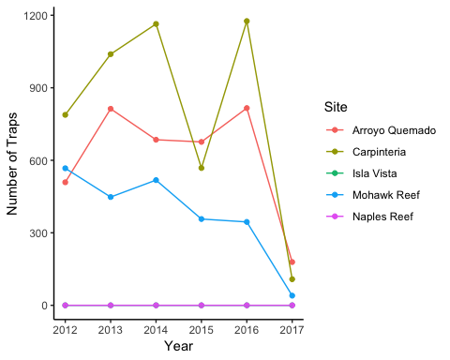

**Figure 1: Fishing Pressure at Five Locations in the Santa Barbara Channel (2012-2017)** Total annual number of commercial lobster trap buoys counted at Arroyo Quemado, Carpinteria, Isla Vista, Mohawk, and Naples reefs. Lobster trap buoy counts at Isla Vista and Naples marine protected areas are both zero across between 2012 - 2017. Data collected in lobster fishing season (October through March) every two to four weeks. Data used with permission of Santa Barbara Coastal Long-Term Ecological Research Project1.

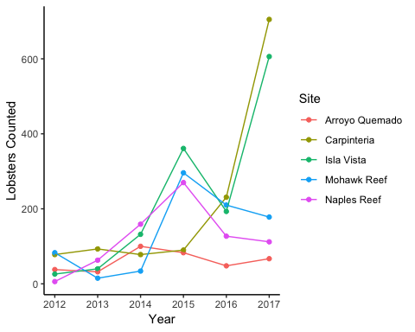

**Figure 2: Fishing Pressure at Five Locations in the Santa Barbara Channel (2012-2017)** Total annual number of lobsters counted at Arroyo Quemado, Carpinteria, Isla Vista, Mohawk, and Naples reefs. Data collected in lobster fishing season (October through March) every two to four weeks. Data used with permission of Santa Barbara Coastal Long-Term Ecological Research Project1.

Figures 4 and 5 show mean lobster carapace sizes in 2012 and 2017 at the two MPA sites where lobsters were measured.  Figure 4 is Isla Vista, and Figure 5 is Naples Reef.

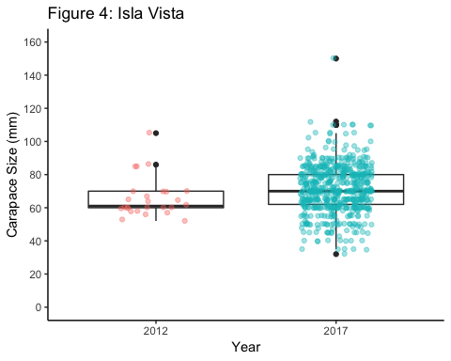 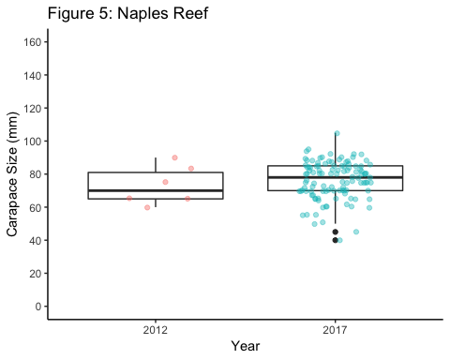

**Figures 4-5: Lobster Carapace Sizes at sites inside Marine Protected Areas (2012 and 2017)** Lobster carapace (mm) data collected at two Long-Term Ecological Research sites within Marine Protected Areas in the Santa Barbara Channel: Isla Vista (n=26 in 2012, n=606 in 2017) and Naples Reef (n=6 in 2012, n=112 in 2017). Mean lobster carapace size was greater in 2012 than 2017 at both locations, but did not differ significantly at Isla Vista [t(630)=-1.885, p=0.06, α=0.05] or at Naples Reef [t(116)= -0.68, p=0.50, α=0.05]. Pairwise comparison at Naples Reef yielded no significant difference.

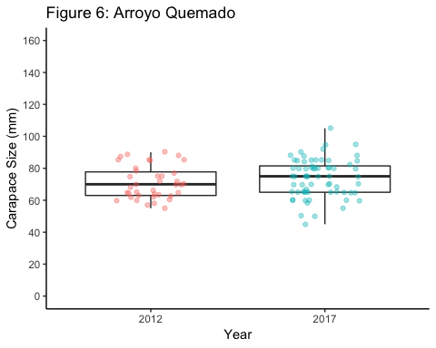 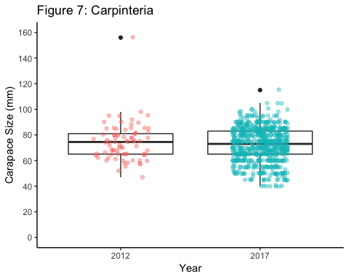

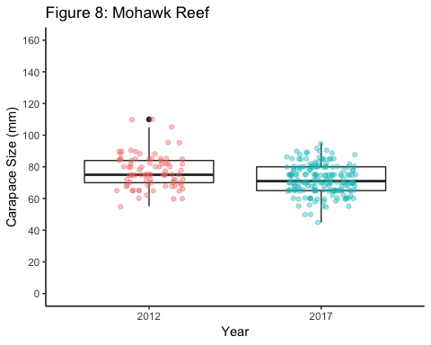

**Figures 6-8: Lobster Carapace Sizes at sites outside of Marine Protected Areas in 2012 and 2017** Lobster carapace (mm) data collected at three Long-Term Ecological Research sites outside of Marine Protected Areas in the Santa Barbara Channel: Arroyo Quemado, (n = 38 in 2012, n = 68 in 2017), Carpinteria (n = 78 in 2012, n = 705 in 2017), and Mohawk Reef (n = 83 in 2012, n = 178 in 2017). Mean lobster size only differed significantly between 2012 and 2017 at Mohawk Reef [t(259)= 4.07, p<0.001, α=0.05] with an effect size of 0.54 (medium). Mean lobster size did not differ significantly at Arroyo Quemado [t(103)= -1.26, p=0.21, α=0.05] or at Carpinteria [t(781)= 1.34, p=0.18, α=0.05] Pairwise comparison at all other sites yielded no significant difference.

**Table 1: Mean Difference in Lobster Size by Site Between 2012 and 2017.** Summary statistics including mean lobster sizes at each site in 2012 and 2017, and the mean difference over the 5-year period (mm). Data used with permission of Santa Barbara Coastal Long-Term Ecological Research Project1

|  |  |  |  |
| --- | --- | --- | --- |
| **Site** | **2012 Mean and SD (mm)** | **2017 Mean and SD (mm)** | **Mean Difference (mm)** |
| Arroyo Quemado | 66.08 ± 12.09 | 71.45 ± 14.32 | 5.38 |
| Carpinteria | 73.00 ± 11.75 | 76.23 ± 11.39 | 3.23 |
| Isla Vista | 74.36 ± 14.62 | 72.23 ± 13.21 | -2.13 |
| Mohawk Reef | 77.25 ± 10.59 | 72.00 ± 9.28 | -5.25 |
| Naples Reef | 71.00 ± 10.15 | 73.90 ± 11.89 | 2.90 |

Figure 9 shows mean lobster carapace size and sample size for lobsters collected at each of the five LTER sites in 2017.  Naples Reef produced the largest lobsters (76.23 mm), while Isla Vista produced the smallest (71.45 mm). Our ANOVA test revealed that true mean carapace length differed between at least two locations (**IN-LINE REFERENCING, OR ANOVA BOXPLOTS HERE?)**.  Subsequent post-hoc Tukey’s HSD testing revealed that though different mean lobster sizes were recorded at each location, the differences were only significant between Naples Reef and Carpinteria, and Naples Reef and Isla Vista **(IN LINE REFERENCING)**.  Lobsters at Naples Reef have carapaces 4.00 mm larger than those measured at Carpinteria on average, and the effect size is small **(IN LINE REFERENCING)**.  Lobsters at Naples Reef have carapaces 4.78 mm larger than those measured at Isla Vista on average, and this effect size is also small **(IN LINE REFERENCING).**Thus, we conclude that location and other factors associated with location, such as fishing pressure, or physical or chemical conditions, do not affect lobster carapace size, as samples collected from most locations are not significantly different from one another, and the only two significant differences observed are very small.

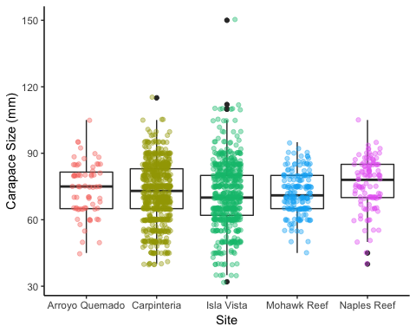

**Figure 9: Mean lobster carapace lengths and samples sizes at five locations in the Santa Barbara Channel (2017).**Mean lobster carapace length (mm) measured at five locations: Arroyo Quemado, Carpinteria, Isla Vista, Mohawk Reef, and Naples Reef, all Long-Term Ecological Research sites.  Mean carapace length only differed significantly between Naples Reef and Isla Vista and between Naples Reef and Carpinteria [F(4)= 3.424, p=0.0085, α=0.05] with post-hoc Tukey’s HSD; all other pairwise comparisons yielded no significant difference. Effect size of both differences was small (Cohen’s D = 0.34 and 0.31 respectively).

Table 2 shows the proportions of lobsters above and below the legal capture size of 82.6 mm in carapace length measured at the five locations in 2017.  Mohawk Reef (87.6%) had the highest proportion of lobsters of illegal size, while Naples Reef (68.7%) had the lowest proportion of lobsters of illegal size.  Chi-squared analysis revealed that these differences are significant, and there is a relationship between location and proportion of lobsters below illegal size.  Marine Protected Status of the test site is a logical potential explanation for this relationship, as lobsters living under protected status for five years would be expected to be larger.  However, while Naples Reef, one of the two MPAs studied, produced the lowest proportion of lobsters of illegal size, the other MPA of Isla Vista had the second highest proportion of lobsters.  This suggests that Marine Protected Status is not the primary factor explaining the relationship between location and proportion of lobsters of illegal size. Since lobsters are mobile animals and can easily leave MPAs, perhaps absolute distance to popular trapping areas, regardless of Marine Protected Status of the test site, would be a more sufficient explanation.  However, this is beyond the scope of our current research and analysis.

**Table 2: Mean lobster carapace lengths and samples sizes at five locations in the Santa Barbara Channel (2017).**Mean lobster carapace length and standard deviation (mm) measured at five locations: Arroyo Quemado, Carpinteria, Isla Vista, Mohawk Reef, and Naples Reef, all Long-Term Ecological Research sites.

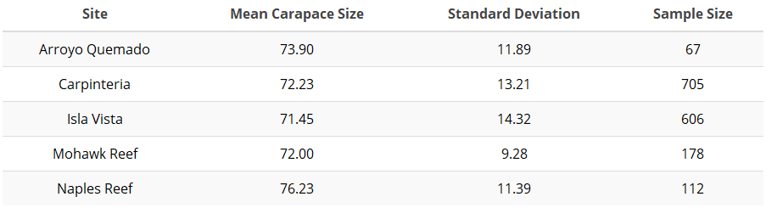

Thus, we conclude that lobsters are the same size at all locations, as there is no significant difference in mean carapace size between lobsters collected at most locations, and the only two differences observed are very small (roughly 6% of body mass at both locations).  Location, and others factors associated with location (such as fishing pressure) do not affect lobster size.

**Table 3: Number and Proportion of Legal and Illegal Lobsters.** Count and proportion, in italics, of lobsters at each site that are of legal or illegal fishing size (82.6 mm). Data used with permission of Santa Barbara Coastal Long-Term Ecological Research Project1

|  |  |  |
| --- | --- | --- |
| **Site** | **Legal Lobsters** | **Illegal Lobsters** |
| Arroyo Quemado | 16  *0.24* | 51  *0.76* |
| Carpinteria | 179  *0.25* | 526  *0.75* |
| Isla Vista | 130  *0.21* | 476  *0.79* |
| Mohawk Reef | 24  *0.13* | 154  *0.87* |
| Naples Reef | 37  *0.33* | 75  *0.67* |